Assignment 5 report

Yixin Yin

In this assignment, I implement bump mapping on the floors, walls and celling. I also implement texture on the duck. The duck will move in the room again and again.

You can press “r” to shoot at the duck.

You can press “+”, “-” to change the speed of the duck.

You can press “wsad” to move the camera. BUT NEVER MOVE THE CAMERA TO THE OTHER SIDE OF THE DUCK.

You can press left arrow and right arrow to change the angle of the camera that is looking at.

The faster the duck is, if you hit the duck, the higher scores you will get.

But do not move the viewpoint to another side of the duck. If you shoot at the other side, a wrong direction warning will be on the screen. If you shoot behind the duck, a wrong direction warning will be also on the screen.

Score and warning

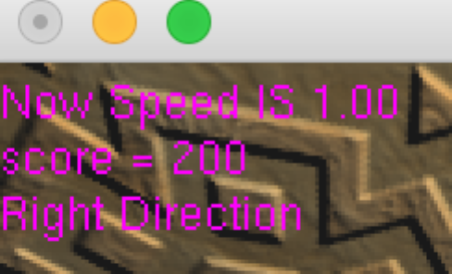

Right direction.

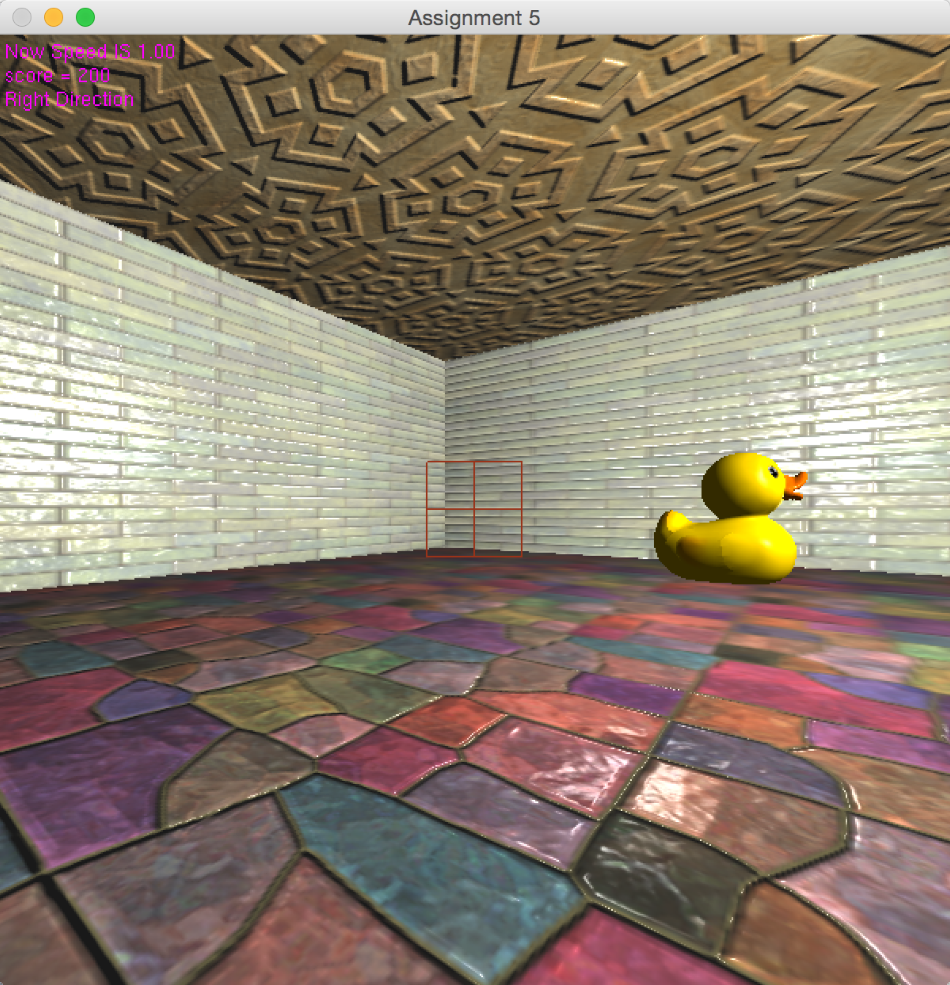

Wrong direction

